Digital Wireless Electrical Food Bag Keeper

*Ideated by Sulaiman Alsharji*

**Introduction**

We are living over modern age which requires quickness, saving money, better quality and more entertainment. Digital wireless electrical food bag keeper could provide better life for human beings due to maintain and refresh the food accord to danger zone temperature based on type of food and its size, the productivity, busyness and hardworking will be in great harmony with our ideated innovation.

**The innovative idea**

High quality Digital wireless Food bag Keeper which will be made via stainless steel inner pot and both of stainless steel plus rigid plastic externally. The function is to maintain food via increasing and decreasing temperature between -18 Celsius (°C) keep frozen foods or colder to 4 Celsius (°C) keep refrigerated foods or colder and from 60 Celsius (°C) to above keep hot foods or hotter to keep food healthy, and fresh from any place which provided rigid plastic cover, highly digital setting touch screen and top quality plastic handle. The bag could be sated plus functioned via highly digital setting touch screen. As well it could be controlled by digital setting touch screen, remote control food bag keeper, tablet or pad and smart phone via an app.

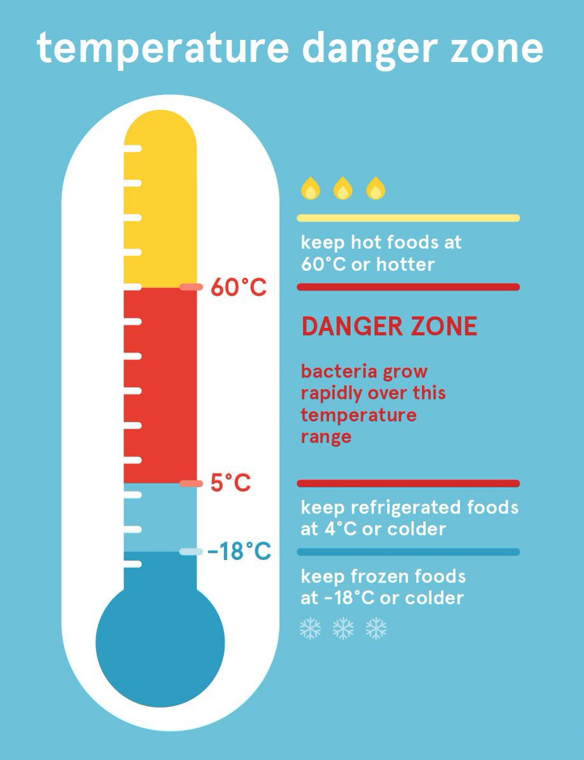

Source: <https://euagenda.eu/news/559671>

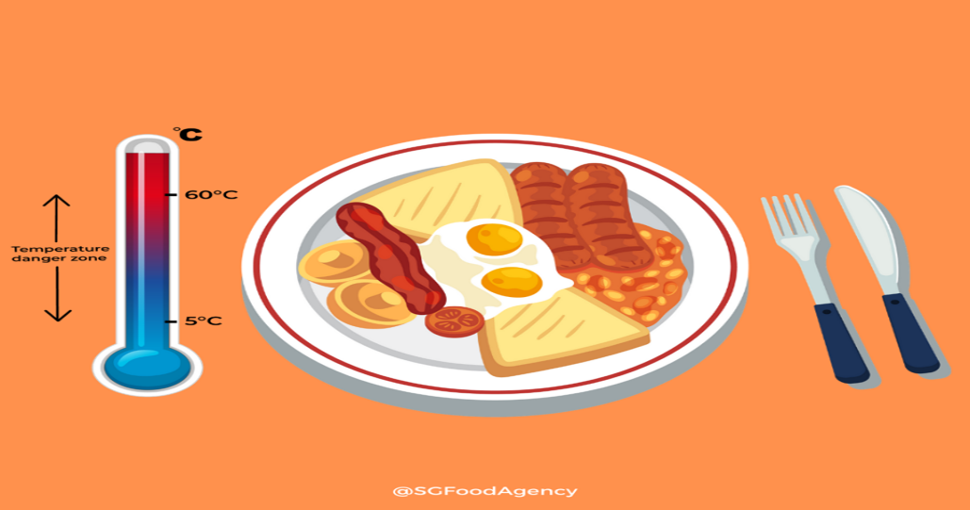

Source : <https://www.sfa.gov.sg/food-for-thought/article/detail/what-is-the-temperature-danger-zone-for-food>

**Rigid plastic cover Highly digital setting touch screen Top quality plastic handle**

**Specification**

|  |  |
| --- | --- |
| **Size** | 2 Liters. |
| **Intelligent Program** | 3 Intelligent Program: -18 Celsius (°C) keep frozen foods or colder, 4 Celsius (°C) keep refrigerated foods or colder and 60 Celsius (°C) to above keep hot foods or hotter. |
| **Power** | Power 750W. |
| **Power Source (Charger)** | 220V – 240V, 50Hz – 60Hz.(19V- 4.74A) |
| **Weight** | 2.45 Kg (5.4 Ibs). |
| **Dimensions (CM)** | 28H X 17.5W X 36L. |
| **Warranty** | 1 year. |
| **Package content** | Stainless steel inner pot, rigid plastic cover, highly digital setting touch screen, top quality plastic handle and Powerful global wireless sensor. |

**Point of View (POV) Statement**

|  |  |  |
| --- | --- | --- |
| User | Needs | Insight |
| Customers who looking to have food or feed, carry the food to anywhere and from everywhere easily. Specially these who are highly busy, hardworking and productive. | To maintain a quality of their hot foods or hotter and fresh.  To maintain a situation of their cold foods to be colder and good for period of time as the like.  To maximize flexibility and simplicity.  Could be engaged from anywhere and with many options.  Could be functioned over any language with international standards. | Big reduce in expenditure, fresher taster food, less time and efforts.  Big reduce in expenditure, very suitable for grills plus barbeque. As well very hand for picnic, trip or travel.  Could be adjusted, seted and controlled easily with low cost, low time, in many moods, less efforts, from anywhere.  Could be function through many device whether by digital setting touch screen, remote control food bag keeper, tablet or pad and smart phone via an app, which offers variety.  It promotes diversity for any utilizer from any country. |

**How Might We (HMW) Statement**

How Might We (HMW) we design a robust digital wireless electrical food bag keeper that push limits of extremely hard working, busy and productive human begins chiefly, for customers who looking to execute refreshing their food within fast time and high accuracy, easy carry, big flexibility, very adaptable, extremely smart, lower cost and comprehensively diverse.

* Digital wireless electrical food bag keeper is very various plus suitable accords to functions, needs, users and advantages.
* High degree of trust and transparency that provided by digital system extremely clear, precious and easy to recognize to gain best results.
* Very healthy with international danger temperature zone rates could serve every type over any temperature with great level of healthiness, freshness and deliciousness.
* Modern technology which run through greatly developed microprocessor which arrange pressure, seamless electricity controlling the heat plus time duration based on food size and type making sure that the preserveness , refreshment and heating very well.
* Certainty of functioning due safe, cheap, swift, with no errors, simple maintenance and clean.
* Much solid and secured without noise, low heat, no smells, internal stainless steel pot enhance healthy service for food plus external stainless steel very rigid to withstand all circumstances.
* Optimally safe and peaceful high – tech device which provide various functions accord to international standards and full digital use manual via touch screen.
* Much easy to be recharged via genuine quality wireless charger.

**Customer journey map**

**Empathy user map**

Users are daily consumers and mostly their ages between 18 – 80 years old whether males or females around the world.

|  |  |
| --- | --- |
| ***Says***   * I require something reliable and transparent. * Product is an advantage to me. * I want to receive full data about my transaction, product specification, features and price. * I want to receive my delivery highly trusted, guaranteed and as I ordered. | ***Thinks***   * Am I getting optimum price? * Am I getting special offer? * Am I having discount? * Would it be useful and beneficial? * Will it reach on time? * What is a super about the product? * Anything missed? * I hope things will go and be will? |
| ***Does***   * Prepare budget. * Make comparison about products. * Make comparison about prices. * Perform contacts. | ***Feels***   * Superb. * Confused. * Anxious. * Happy. * Stress. * Passion. * Satisfaction. * Untrustable |

**Press Release**

|  |  |
| --- | --- |
| **Heading** | Maximizing health, reducing time, decrease money and lower efforts via Digital Wireless Electrical Food Bag Keeper. |
| **Sub - Heading** | We to give the best experiences via outstanding customer service, attractive competitive prices, high security, great transparency and big trust by reducing time, efforts and cost. |
| **Summary** | Our ideated product provide great experience for customer due the functions and features which it promote full maintain and refresh for the food & beverage for any temperature. |

|  |  |
| --- | --- |
| **Problem** | There are many problems happens because there are no ways to maintain, keep, refresh and carry food dynamically everywhere with low prices, very fresh and healthy whether hot or cold. |

|  |  |
| --- | --- |
| **Solution** | Our ideated product of FMCG industry which provide effective and beneficial solutions for any customer:   * Suitable accords to functions, needs, users and advantages. * High degree of trust and transparency. * Very healthy plus covering international danger temperature zone rates standards. * Certainty of functioning due safe, cheap, swift, with no errors, simple maintenance and clean. * Optimally safe and peaceful high – tech device.     Accord to FMCG sector Digital Wireless Electrical Food Bag Keeper which enhances spectacular solution for having fresh food or maintaining it through very secure, trust, transparent and accurate, from any place and could be shifted to anywhere through an advance digital high technology which could be hired from everywhere. |

|  |  |
| --- | --- |
| **Quote of us.** | ‘Our goal is to promote human beings lives easily, quickly, less cost and high quality.’  -Sulaiman Alsharji- |
| **How to get started?** | Visit our future website  www.foodbagkeeper.com with details to buy ideated product and get full detail about it plus order it |
| **Customer Quote.** | ‘An experience of enjoyment, saving money and providing great easy way of food enhancement in very modern advanced way’. |
| **Call to action.** | General Call to Actions  Find us for location.   * Read more for more information. * Like as feedback. * Watch now for demonstration demo. * Download for specifications. * Donate for charitable purposes about Sultanate of Oman. * Add to cart for adding the product of customer’s online shopping cart. * Search for searching about product. * Subscribe to link customer with certain product. * Buy now for purchasing a product. |

**Prototype of design**

**Prototype Testing**

|  |  |  |  |  |
| --- | --- | --- | --- | --- |
| **Interview Questions** | **User 01** | **User 02** | **User 03** | **User 04** |
| What did you  like about the  Product? | Very smart | Easy to use and control | High quality product | Extremely developed touch screen |
| What did you  dislike about  the product? | High  subscription  fees | Less intuitive  user interface | Lack Of  customer  support | Shipping price |
| How did you  feel about  the product? | Saver of time, money and nice food refresher | Effortless  experience | Very handy and beneficial | Very safe and secure |
| Any features  you want to  remove? | Chatbot services | Nothing | Plenty of details | Subscription  fees |
| Any features you  want to add? | More updates | Intuitive user  interface | Top level customer service | Website design |
| Would you  recommend this  product? | Yes | yes | yes | yes |
| Rating you  would assign to  product from 1  to 5? | 5 | 4 | 3 | 5 |

**Product price**

The net price of digital wireless electrical food bag keeper is 132 OMR for each.

The local shipping price all over Oman is 15 OMR and internationally is 30 OMR.

**Competition and context**

To reach high level of productivity, transparency and trust we have to engage:

1- Feasibility:

* Disruption to boom the market.
* Agile business good be very effectful to optimize the productivity.

2- Desirability:

* To implement Agile Methodologies.

**Design Thinking Conclusion**

Based on the feedback, we can incorporate the following changes:

1. Integration of Artificial Intelligence to make platform more intuitive which respond to voice request directly.
2. Survey based on customer evaluation.
3. Digital maximizing automation to the highest level to reduce efforts, time and more productivity.

**Roadmap to Disruption**

* Personal assistant enhancement of AI programs could talk to humans and give solutions via searching due the web.
* Understand by customer service the issues plus questions from customers and get sharp resolutions.
* Provider of smart contract which promoting, Accuracy, less time, transparency, saving money, no third party and paper free, security, trust, better communication, backup of data and extremely effective.

**Business model canvas**

|  |  |  |  |  |  |  |  |  |  |  |
| --- | --- | --- | --- | --- | --- | --- | --- | --- | --- | --- |
|  |  | *Designed for:* | | | | *Designed by:* | | *Date:* | | *Version:* |
| **Business Model Canvas** | | FBK | | |  | S.Alsharji |  | 2/4/23 |  | 1 |
|  |  |  | | | |  | |  | | |
| **Key Partners** | **Key Activities** | | **Value Propositions** | | | **Customer Relationships** | | **Customer Segments** | | |
| Cloud provider (Azure).    Payment provider  Google pay  PayPal. | Maximizing the quality of human beings by have provider to refresh and maintain food.  Entire implementation accord to danger zone temperature international standards. | | Transparency.  Trust.  Super-fast.  Lower expenses.  Smart contracts. | | | Customer service.  Customer support 24/7.  High security.  Feedback.  Transparency + trust. | | Food and Beverage.  Consumer goods.  Shipping fees. | | |
| **Key Resources** | | **Channels** | |
| Requirement due to customer requests such as:  Verification.  Documentation.  Audits. | | Company Website.  Social media platforms. | |
| **Cost Structure** | | | | **Revenue Streams** | | | | | | |
| Creating very developed Food Bag Keeper accord to very high quality material, digital high technology and suitable cloud computing.  Build FMCG industry business via Smart contract.  Reduced transportation, delivery and time cost. | | | | Crowd funding.  Transaction revenue.  Product + shipping revenue.  Recurring revenue. | | | | | | |
|  | | | | | | | | | | |

**Advantages of Business Model**

* 1. No chances of error and dispute as every transaction in digital is observed and recorded by plenty of servers.
  2. Fraud percentage is zero, accord to the level of security which is very high via digitalization.
  3. The transaction easily could be achieved from any spot around the world based on requirement of ID and personal documents.
  4. Top level of transparency pre, during or after the buying or selling via website use manual, demo and customer service.

**Conclusion**

Digital wireless electrical food bag keeper is the option of support, easy life, productivity and transformation. Once there is a proper product to supply human beings need due easy keeping, maintaining and refreshing the life getting easier, faster with better quality. The level of transparency and trust accord to the device is something build unbelievable experience for customer.

**Reference**

Lewrick, M. (2018). The Design Thinking Playbook: Mindful Digital Transformation of Teams, Products, Service: Willey.

Rogers, D. (2016). The Digital Transformation Playbook: Rethink Your Business for the Digital Age.

Perkin,N. and Abraham,B. (2017). Building the Agile Business through Digital Transformation: How to Lead Digital Transformation in Your.

[online]. Available from: <https://www.target.com/b/instant-pot/-/N-4vqn6>

Digital adoption team. (July 4, 2022). [online]. Available from : <https://www.digital-adoption.com/what-is-digital-technology/>